NAME: SAKSHI TIWARI STUDENT ID:2110994818

# SIT209 Software Engineering 2: Developing IoT Applications

# Pass Task: Evidence Learning for the topic

This practical activity focus on deployment of Node.js applications on cloud resources.

Activity 1 Evidence

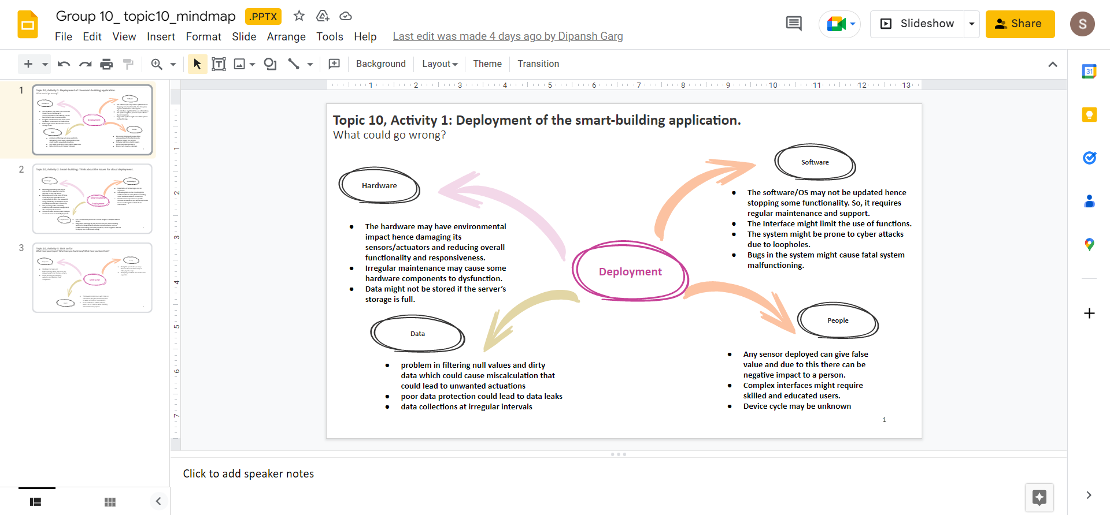

# Activity 2 Evidence

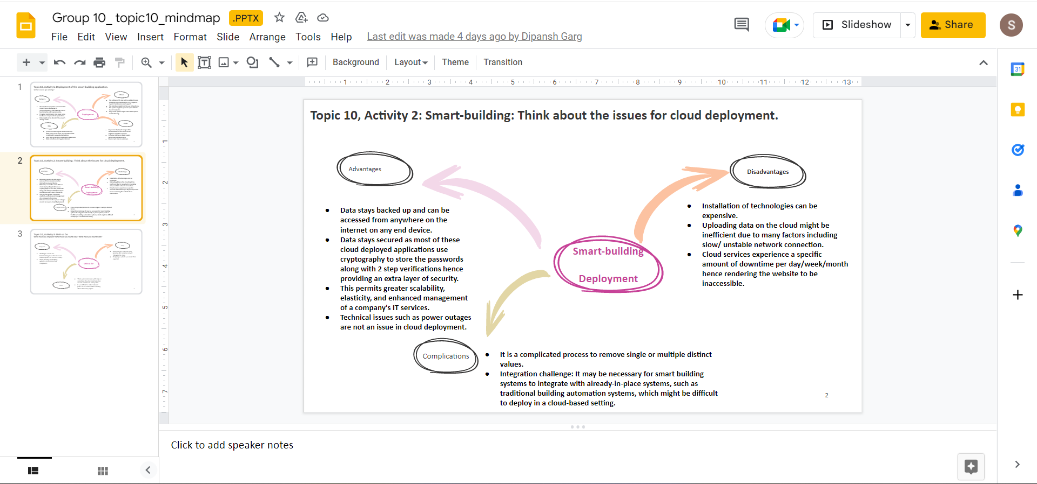

# Activity 3 Evidence

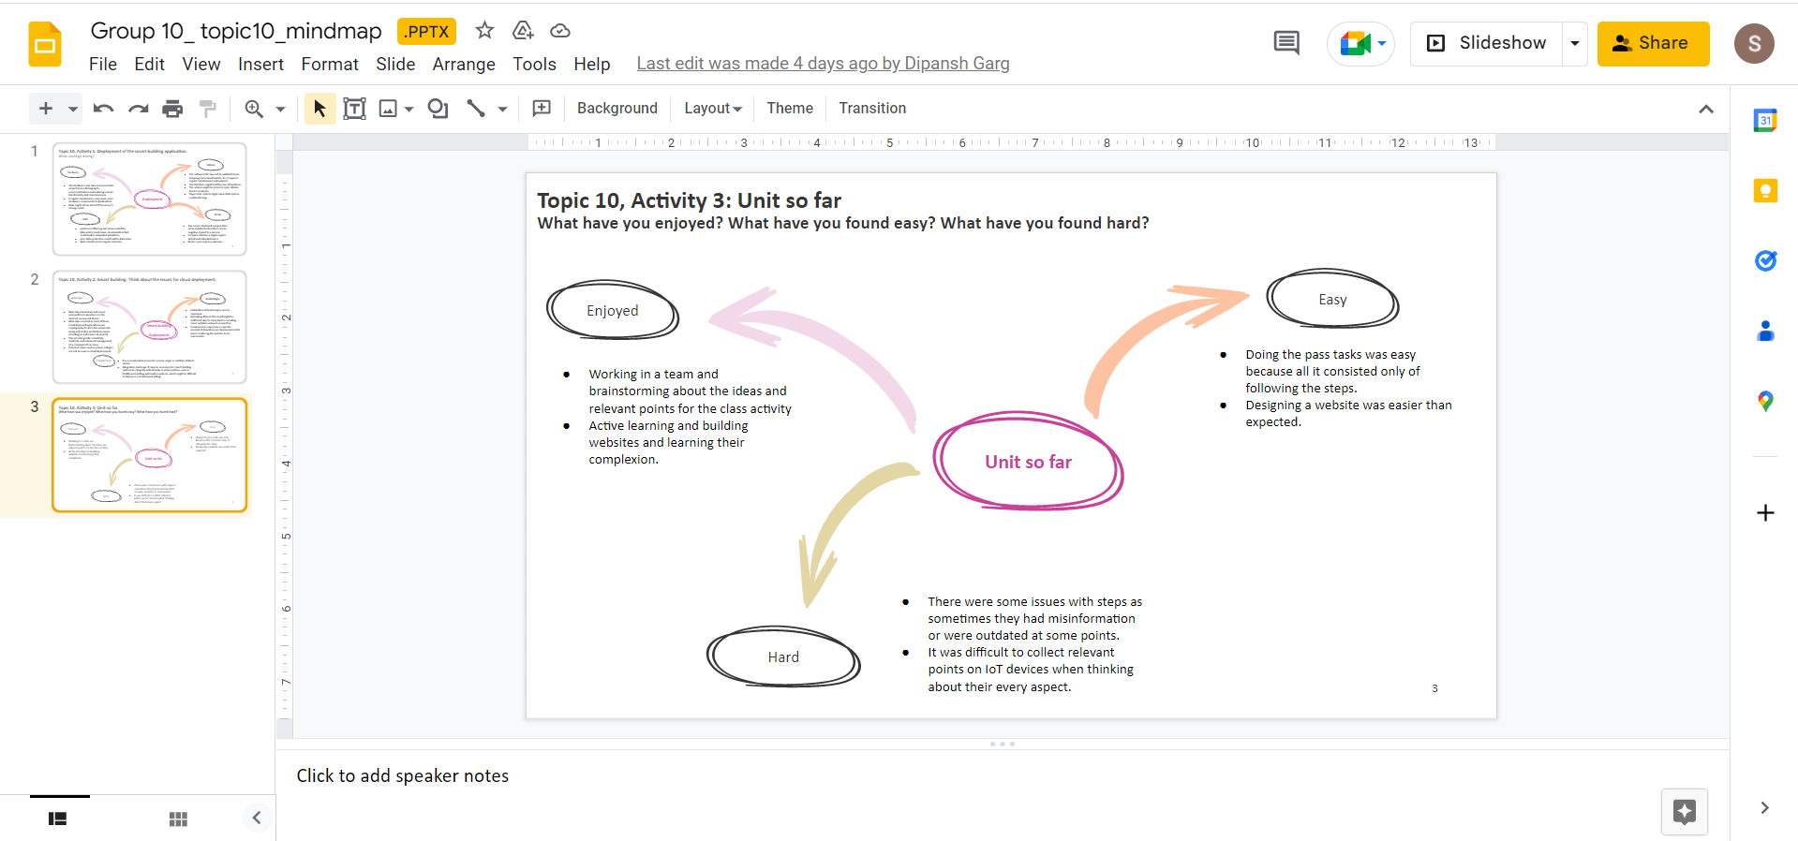

# 

## Practical Activity

First I initialised the node.js project in topic10 folder.

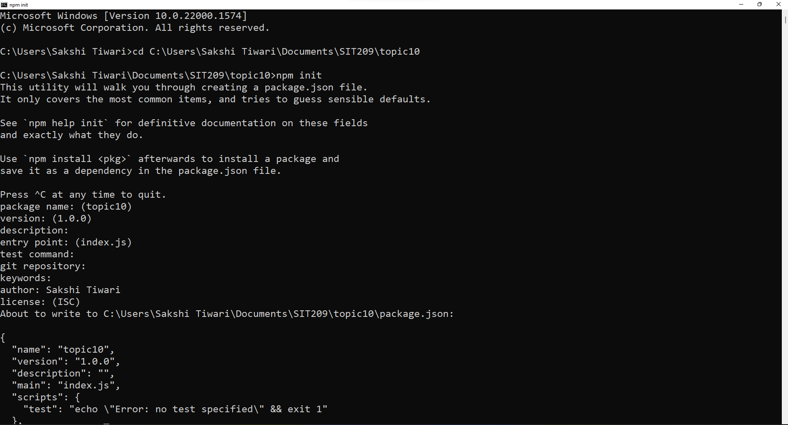

Then I installed the express package.

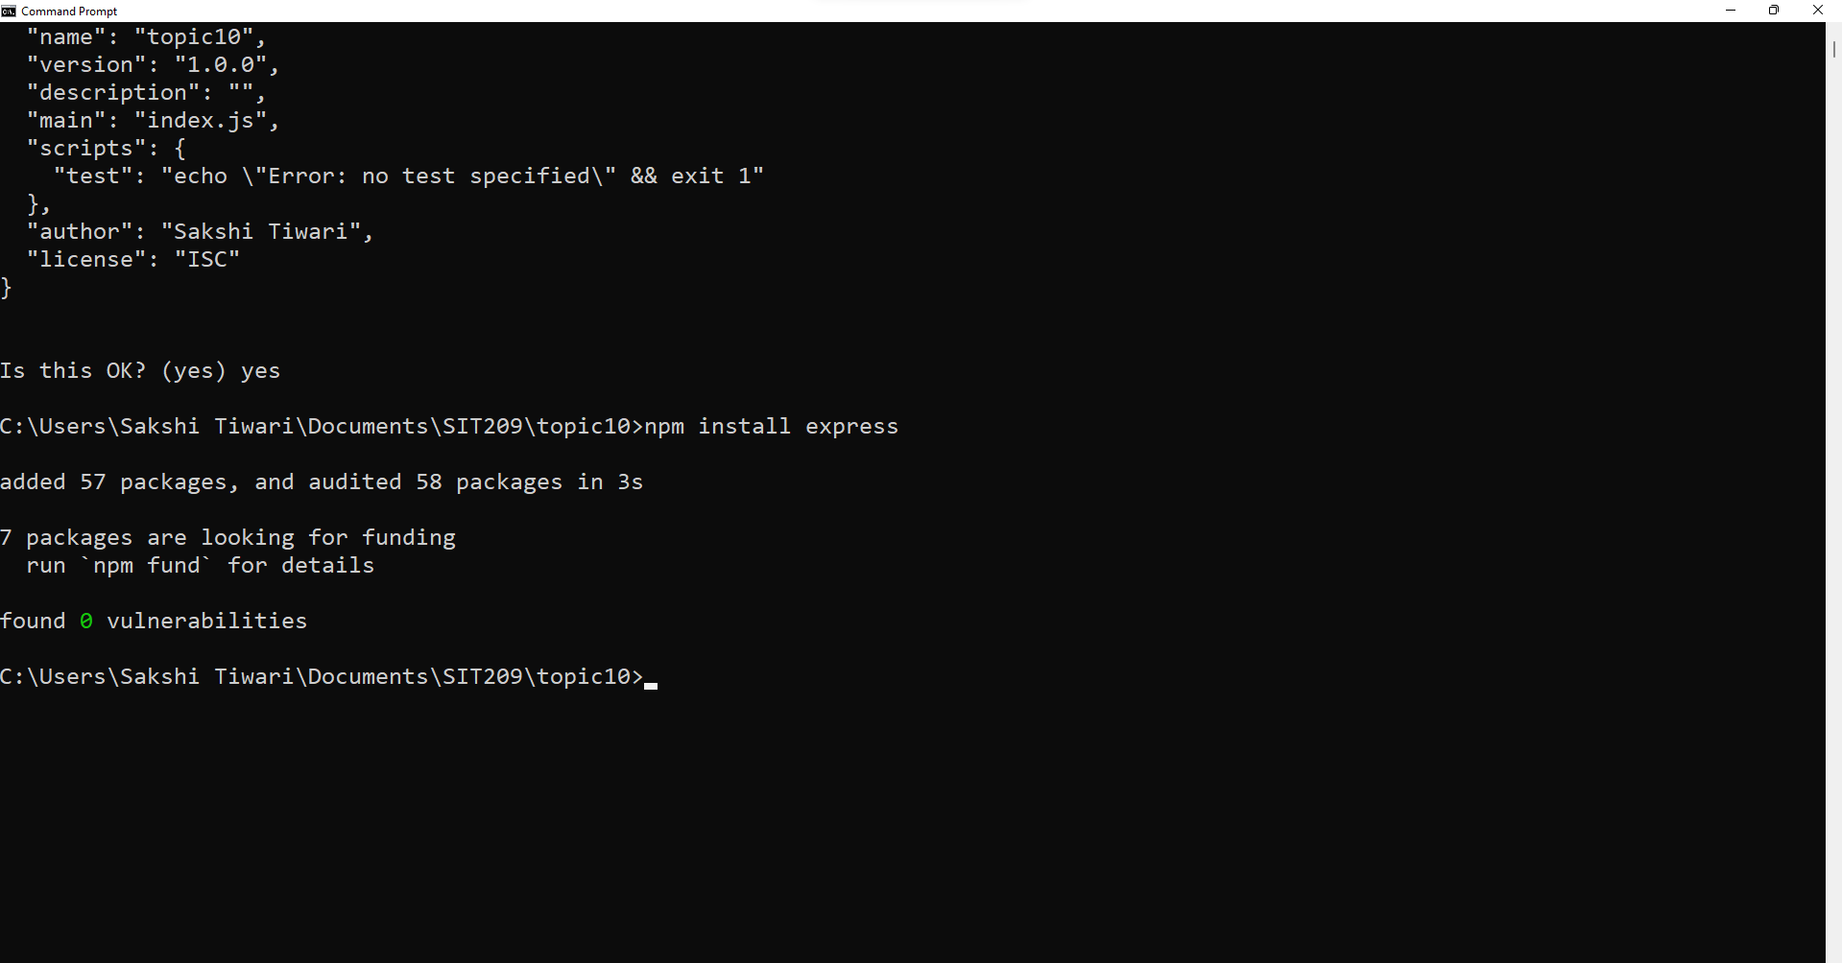

Then I created a new file named server.js

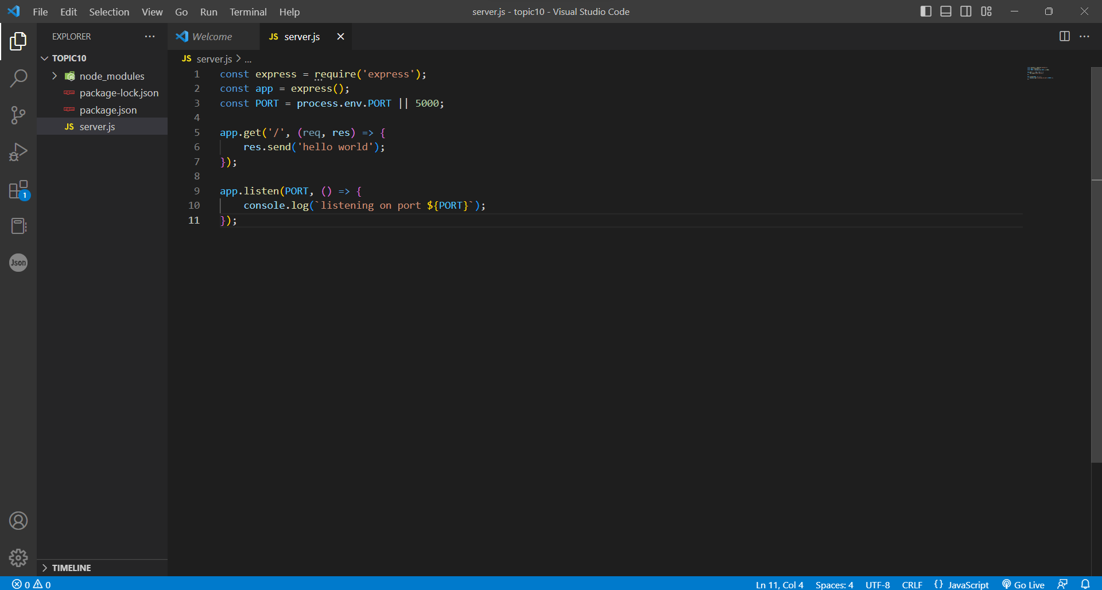

Then I saved the file and run the server.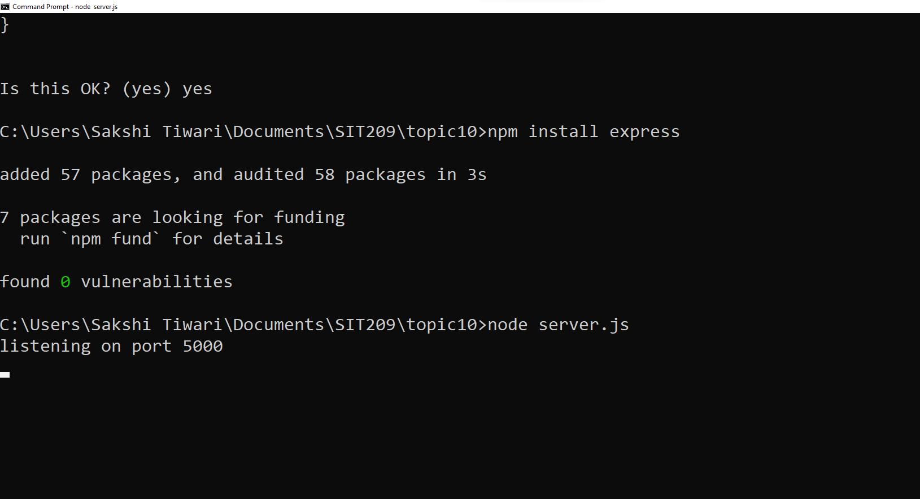

Then I opened a browser and navigate to the server's root address:

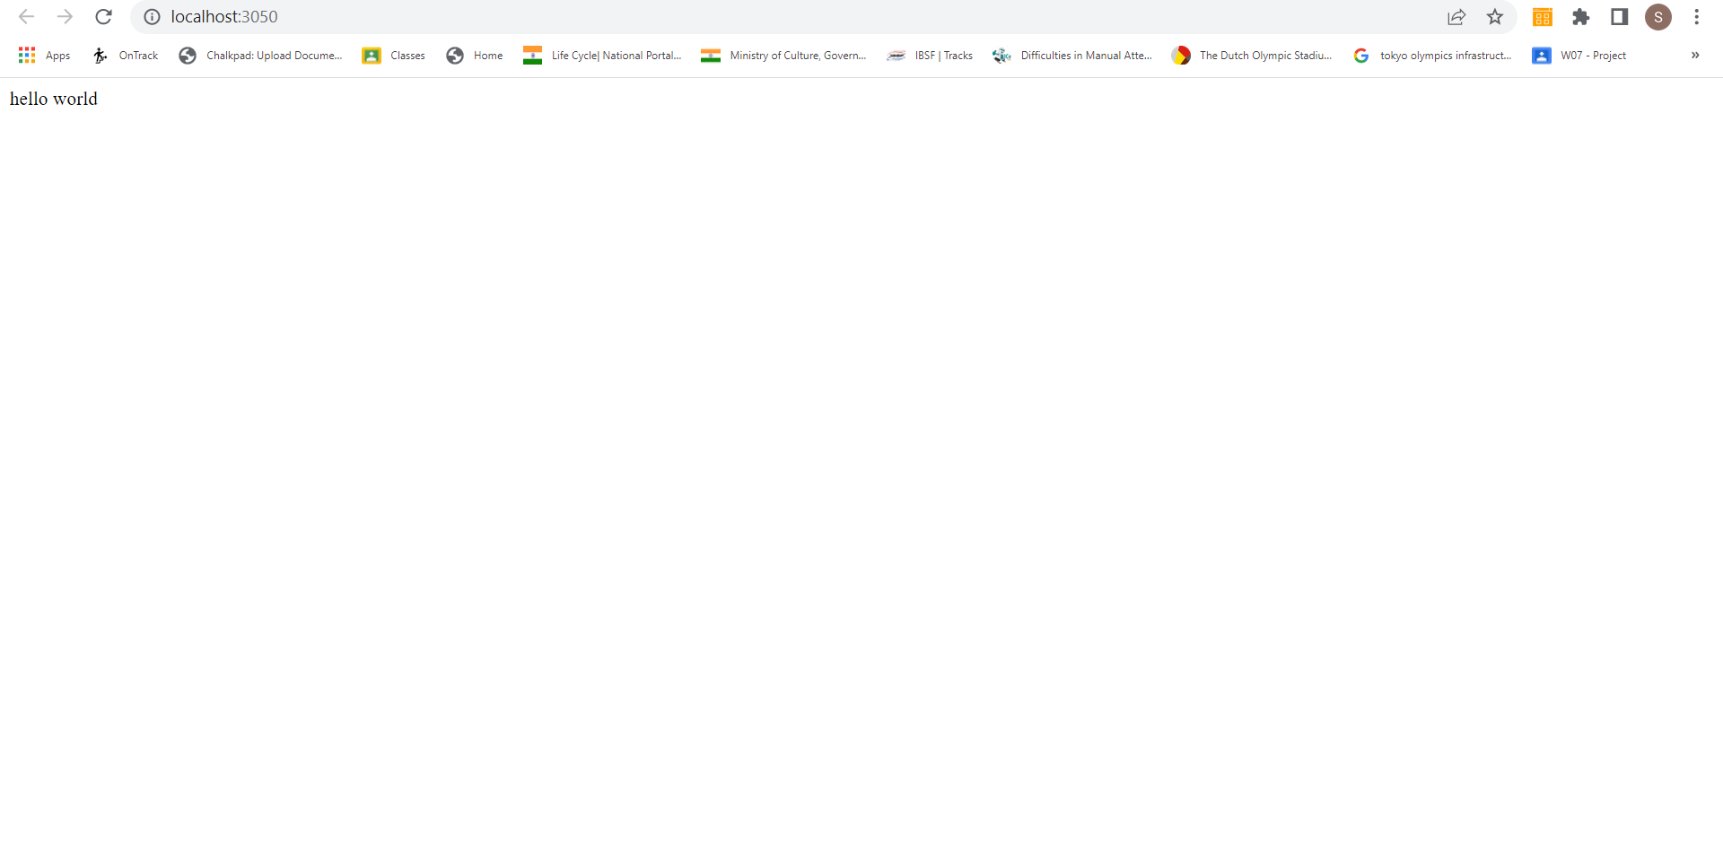



Then I added some packages

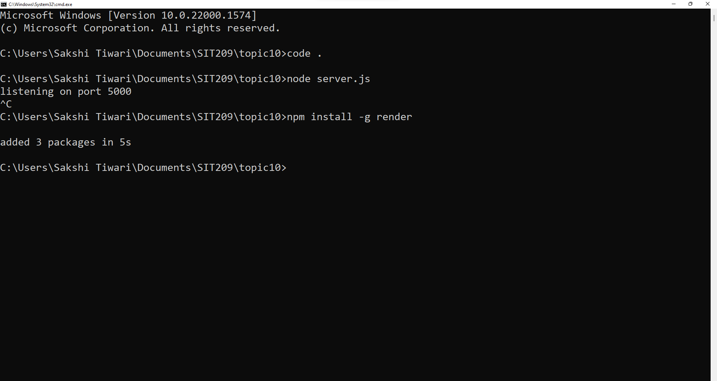

GitHub commit graph

GitHub Code:

# I will comply with the request to apply what I've learned, and if I can help others, I will. The primary focus of this task is on deployment of Node.js based IoT applications. I used Git to set up the project and .

# I learned about Securing a web server with HTTPS - Making use of the Helmet middleware - Making use of the Passport middleware.

# Thank you 😊